**TEAM - 8**

**INDEX**

* **Introduction....................................................................1**
  + Existing Solutions and Drawbacks………………………………..2
  + Proposed Solution…………………………………………………3
* **Mechanical Design…………………………………….4**
  + Chassis……………………………………………………………4
  + Structural Analysis………………………………………………..4
  + Thermal Analysis………………………………………………....6
  + Drive Mechanism…………………………………………………7
  + Rotating Platform………………………………………………….9
  + Fire Extinguishing Mechanism……………………………………9
  + Safety Equipment Compartment………………………………….11
* **Electronic Architecture………………………………12**
  + Power System…………………………………………………….12
  + Key Components…………………………………………………13
* **Software Architecture………………………………..16**
  + Communication…………………………………………………..16
  + Imaging and Audio…………………………………………….....17
* **Cost Analysis………………………………….………18**
* **Future Aspects…………………………….………….19**
* **References.....................................................................20**

**Introduction**

On average, every year, about 25,000 persons die due to fires and related causes in India alone. It is estimated that about **42** females and **21** males die every day in India due to fire. According to the statistics released by the National Crime Records Bureau, fire accounts for about **5.9%** (23,281) of the total deaths reported due to natural and unnatural causes during the year 2012. Many of these deaths could have been prevented, had we taken enough fire protection measures.

And with increasing fire accidents, there is an increase in the number of deaths and injuries of firefighters and is a serious concern to the health of fire-fighters. The following pie-chart (NFPA report) summarizes the injuries caused to the firefighters due to various reasons during the year 2017.

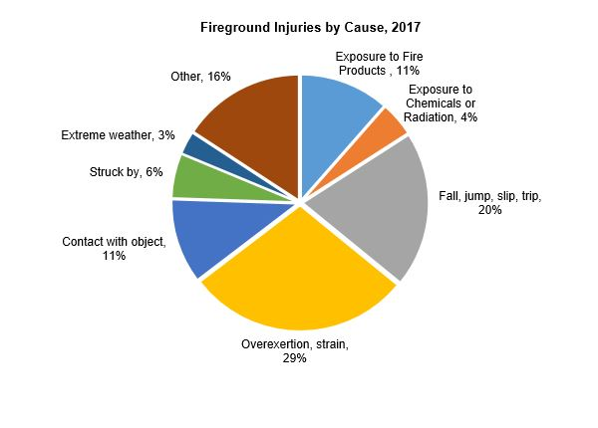

So it doesn’t make sense to **risk one human’s life to save another’s**.

Going with the revolution taking place in the field of automation and robotics, we decided to come up with some solution to increase the survival of the victims as well as to primarily reduce the various risks faced by firefighters.

**Existing Solutions and Drawbacks**

When it comes to firefighting robots, there are quite a few existing models varying in size and functionality. All the existing models are very costly and cost about at least INR 40-50 lakhs. In India, no such bot is being used and the proposal for the first one to be used is pending by BMC Mumbai and it is to be imported from China at a price of INR 92 lakhs.

(Source: Times Now News)

The existing models are either very bulky and although they provide a long range of water targeting, they cannot be deployed in indoor conditions. Being bulky, the cost and power consumption for such vehicles is high.

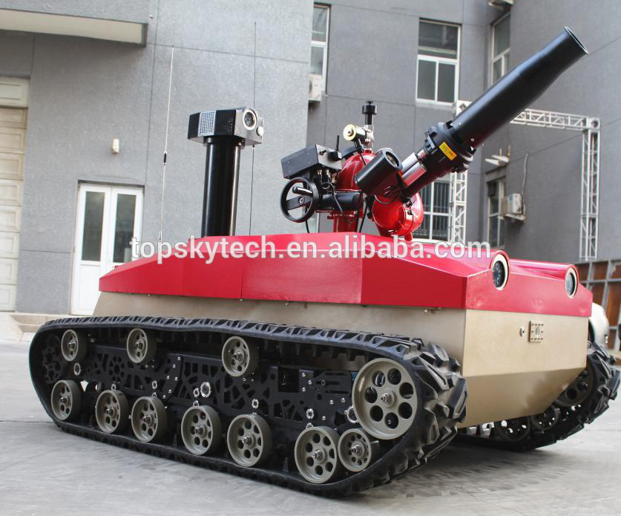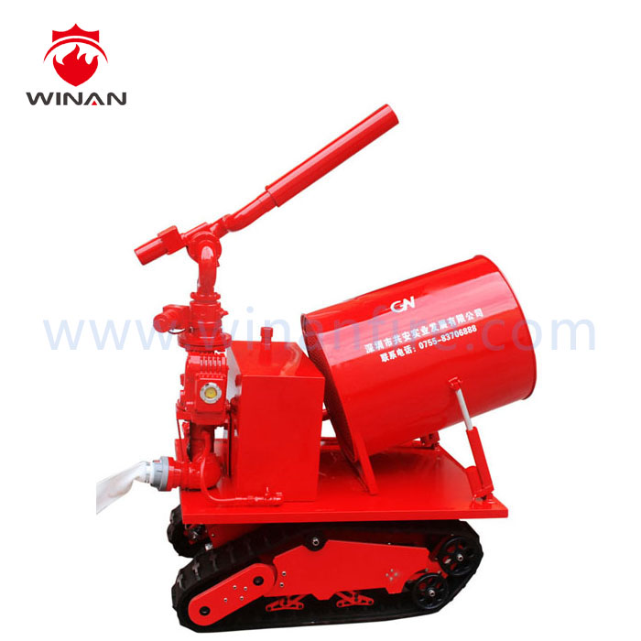 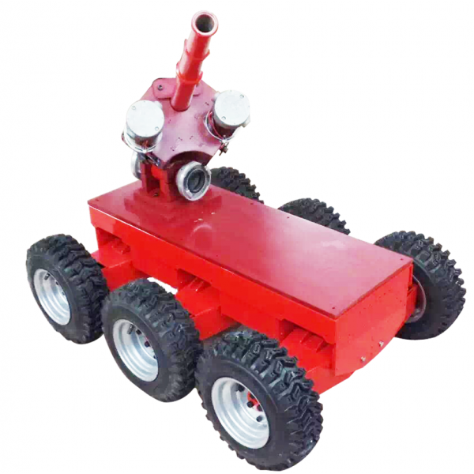

Existing Solutions

The small ones which can be used for indoor purposes are also costly and provide almost zero human assistance for people trapped in fires. In the case of electrical fires, they can’t operate because they use water-based mechanisms to extinguish fires. They also do not use visual sensing elements such as a thermal imaging camera, which is essential in fire situations. Without a thermal imaging camera, detection of humans through smoke and rubble is not possible.

The very rare existing medium-sized robots which consist of a thermal imaging camera or an extinguisher can’t be deployed practically in many indoor conditions due to size constraint.

The existing solutions are not capable of detecting or aiding trapped humans in fire situations as they lack sensing and communication systems, moreover, water-based extinguishing systems can’t be used in electrical or gas-leakage caused fires. In all such cases, a human firefighter is needed to overcome the limitations of a robot. If a robot can’t replace basic human applications in a fire situation, it can’t ensure the safety of any human firefighter. Hence, there is a need for a small-sized cost-effective model which can be practically deployed in indoor fire conditions which can help trapped humans as well as ensure human firefighter’s safety in fire situations.

**Proposed Solution**

**Problem Statement:** To build a semi-autonomous fire-fighting robot capable of replacing/ assisting human fire-fighters during indoor or outdoor fire situations encompassing appropriate audio-visual communication systems and fire-safety equipment for aiding trapped humans, and being capable of extinguishing multiple types of fires, thereby ensuring complete safety of human firefighters in fire situations.

**SAFFV (Semi-Autonomous Fire-Fighting Vehicle)**

Considering the problem, we came up with a product with great potential to replace a human fire-fighter. Following are the major functionalities of the robot-

* Capable of all-terrain traversal with the help of skid steer drive consisting of caterpillar mechanism similar to tanks. Angled front and back extension of belt provides the ability to traverse on debris and rubble giving the bot an all-terrain traversal ability.
* Live thermal imaging and vision feed which can be accessed with the help of Wifi. The thermal camera feed can be easily used to find humans even in the presence of thick smoke.
* Audio feed and audio communication through 2.4GHz radio frequency.
* Full Wireless control of the robot over 2.4Ghz Radio wave frequency
* Provision of a continuous water supply of 10000 cc/min with the ability to increase it as per requirement. Secondary CO2 based fire extinguisher (2kg) to extinguish small fires at a rapid rate.
* Safety box containing gas mask, helmet, and other fire-safety equipment for the survivors.

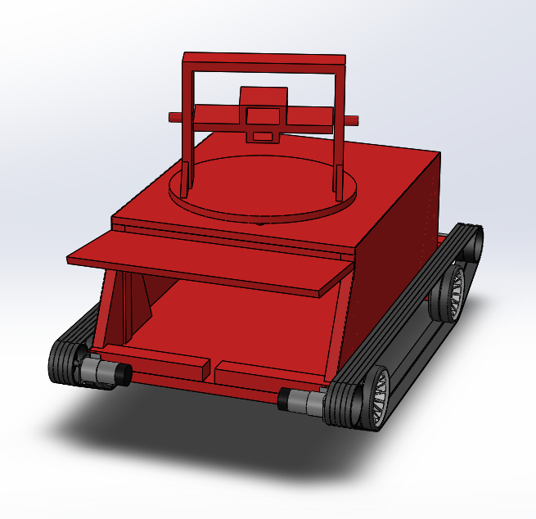

CAD Model of SAFFV Chassis

**Mechanical Design**

**Chassis**

The chassis for the bot is designed as to preserve the electrical pieces of equipment required for proper functioning of the bot in rescue missions. The design is simple and minimal that would assist the bot in easy accessibility in hard to reach places and is such that the structural integrity of the bot is not disturbed. The chassis design was finalized by multiple iterations in design and the material is selected so as to suit the functioning of SAFFV in high temperatures protecting the enclosed equipment.

Center of gravity is kept low to avoid the toppling of robot due to thrust applied on it by the water and also during climbing the inclined surface.

**Structural Analysis**

The prototype prepared has an inner frame made of wooden panels with a covering of galvanized steel plates to provide a low experimentation cost and local and easy manufacturability. Although, the material that would be used in the actual bot will be Carbon Steel for the chassis structure and steel plates as covering, this would provide a robust and cost-effective design which will be quite effective in assisting with extinguishing small house fires as discussed with the static structural and thermal analysis for the chassis and the completed bot.

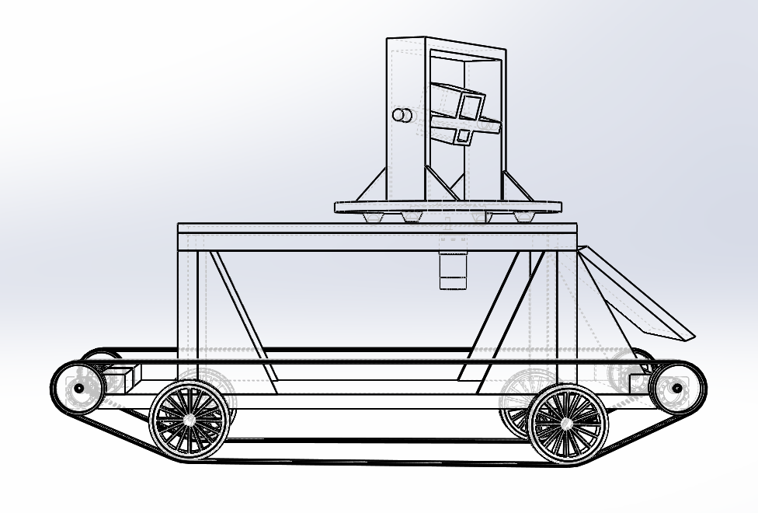 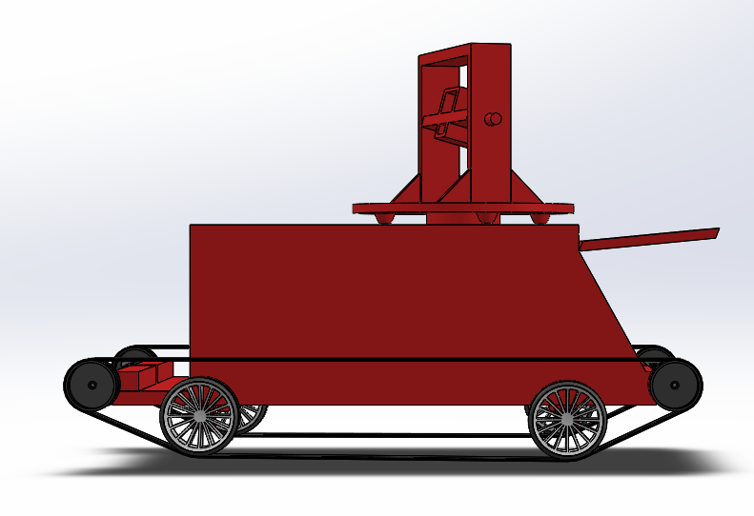

CAD Representation of the Frame

Main forces on the structure are Gravity (g = 9.8 m/s2), thrust force of the jet of the water stream (50N), opposite friction force on the tires which will be calculated as since body is in equilibrium at the instant of throwing water, net force in x direction equals to 0 and we are having 4 tires , So our total force distributed equally on four or these and equals to 12.5 N .

The normal force (309.25 N as weight of body is equal to 31.556 kg) from the ground will pass perpendicular to 4 tires as applied in the Ansys.

Thrust force will be exactly opposite direction to the flow of water.

The opposite static friction force will be exactly opposite to the Fthrust and at tires.

After applying all the forces in Ansys we can see that maximum deformation in the body

is around 10-6 m. (Fig-1).

Result of the prediction was that the maximum developed stress is in the pump holder and equals to 1.1524*106 and our material supports stress upto 1.064*109 which is 1000 times the bearing stress so our statically our bot is robust. (Refer Fig-2, Fig-3)

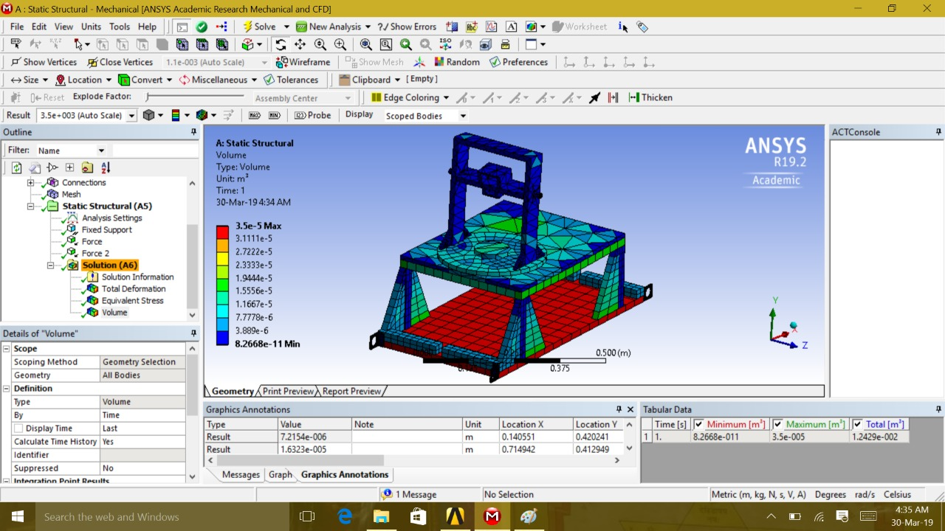

Fig-1

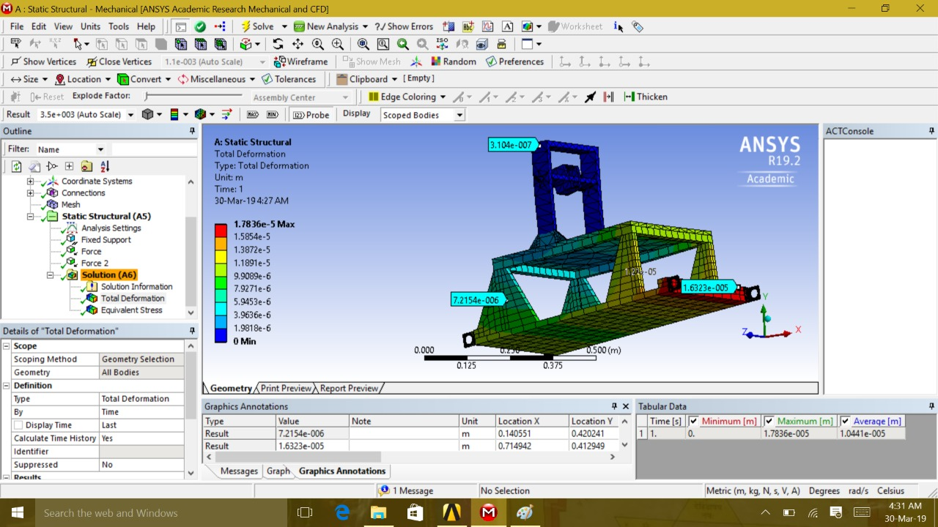Fig-2

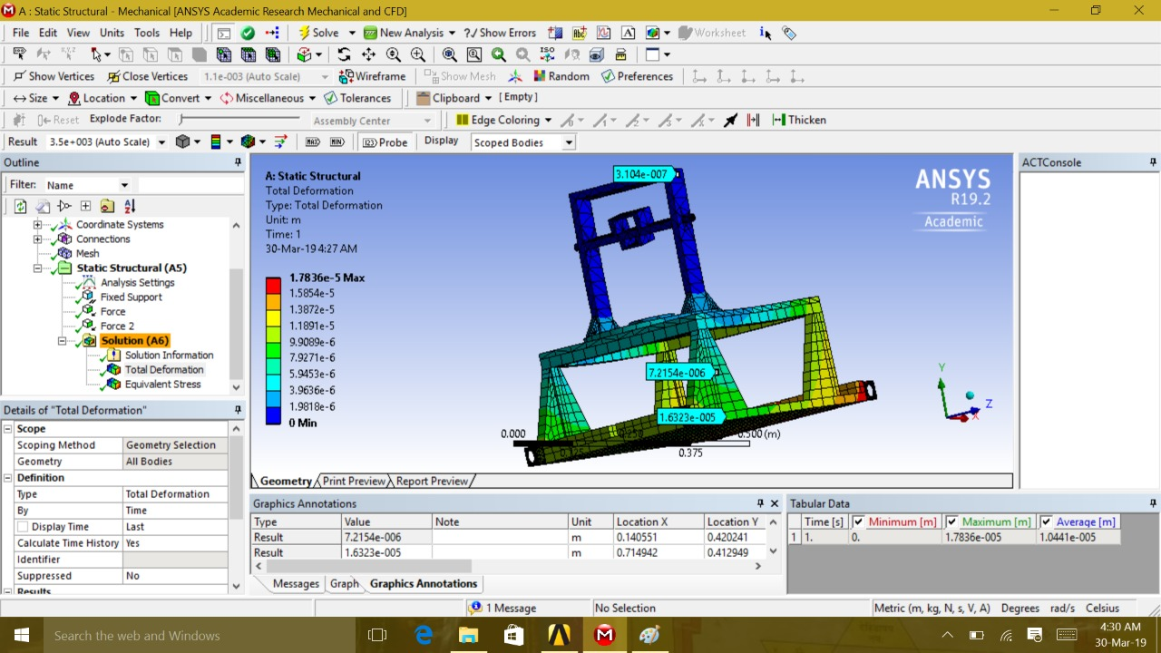

Fig-3

Following are the properties of Carbon Steel which have proposed to use -

* Tensile strength, ultimate 635 Mpa
* Poisson’s ratio 0.27-0.30
* Bulk modulus 140 GPa
* Thermal conductivity 49.8 W/mK
* Melting Point 1538**°** C
* Density 7.85 g/cm3

**Thermal Analysis**

A fix surface temperature was applied due to heating of frontal surface (shown in red in fig) and at a distance of 2 m from fire for constant time radiation flux “ f ”

The temperature of the steel metal plate coverings rises to a high of 70 °C after steady state.

The full transfer of heat in the body was taken to be through convection in the carbon steel chassis of the insides of the bot (film coefficient = 5W /m²)

The results achieved are depicted in figures 4-6

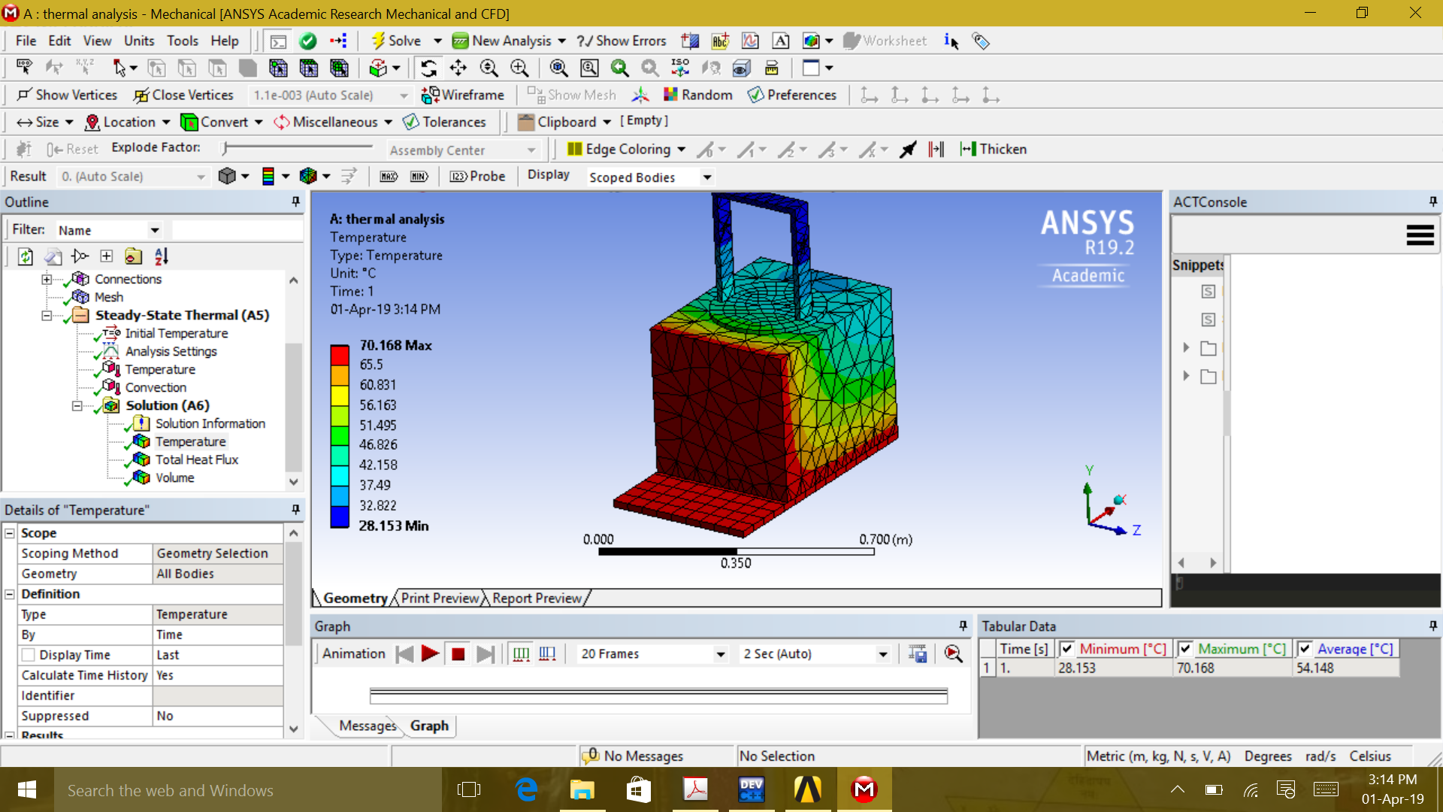

Fig-4

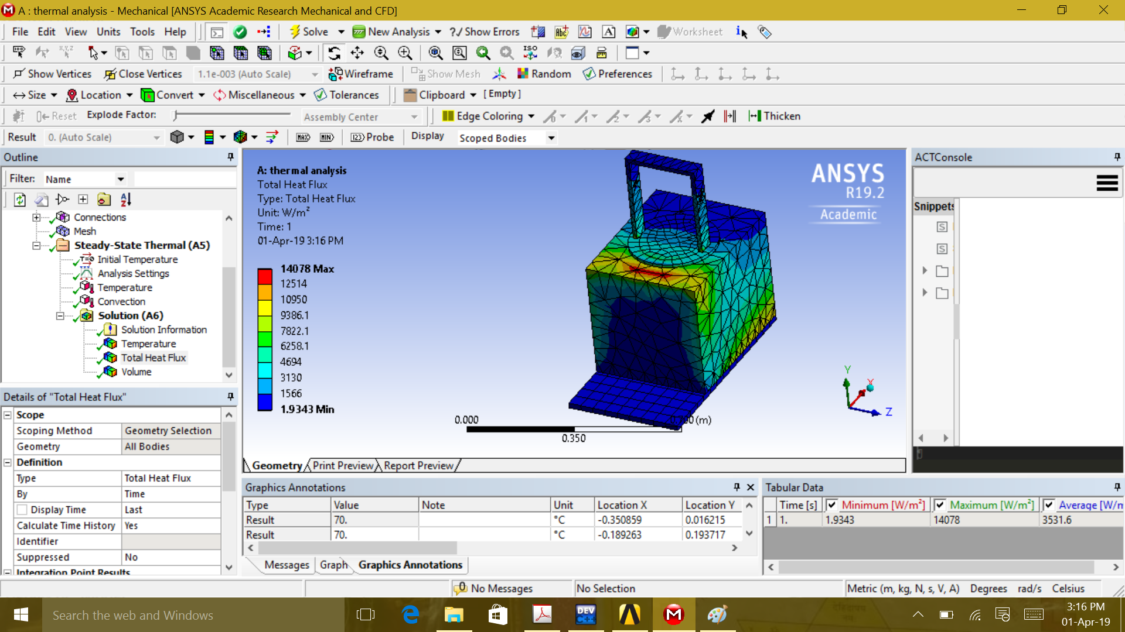

Fig-5

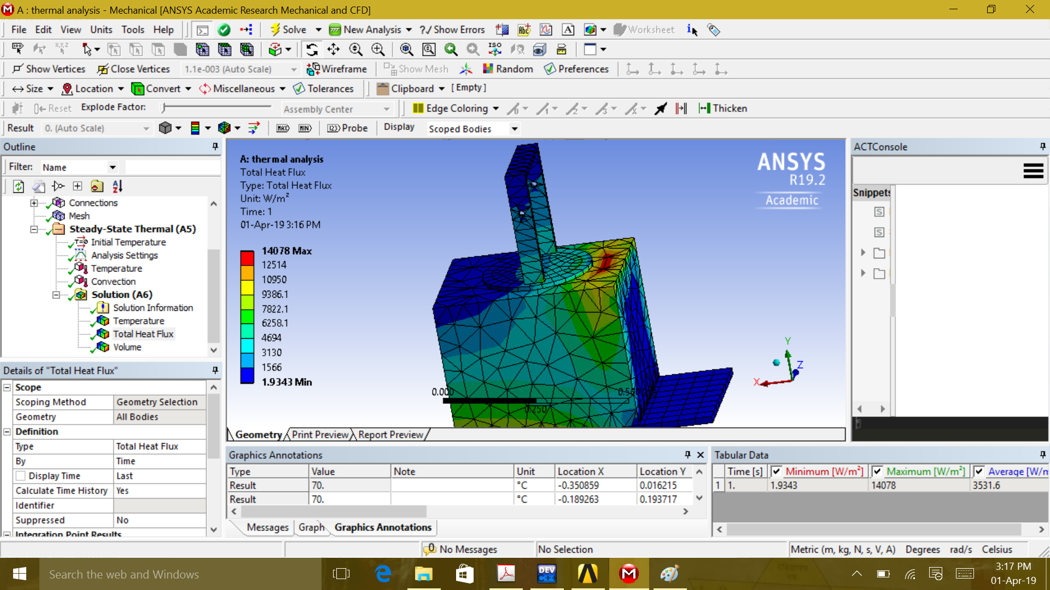

Fig-6

**Drive Mechanism**

Objectives while deciding the driving mechanisms were:

* All-terrain travers ability to make way through rubble or debris in case of large fires.
* High power transfer ratio from driven to driving wheel for better control of the bot.
* Larger contact area of the bot to the ground to reduce skidding of the bot in uneven terrains.

Hence a conveyor belt based differential drive mechanism is used consisting of four 12V DC motors which are coupled to 7cm diameter pulleys which drive the belt supported by four 10cm diameter freewheels. The belt inclination angle is kept 30**°.**

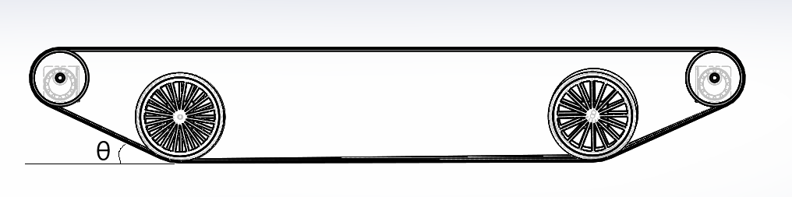

Side View of Conveyor Belt

The belt angle is decided as to keep the belt in tensile stress at all times and the angles considered were as to keep the belt along the common tangents between the driven and driving wheels at all times in the front and the rear drivetrain parts. The above state is indicated in the diagram above. Also, this 30**°** angle is optimum for traversing through debris.

**Selection of Drive Motors**

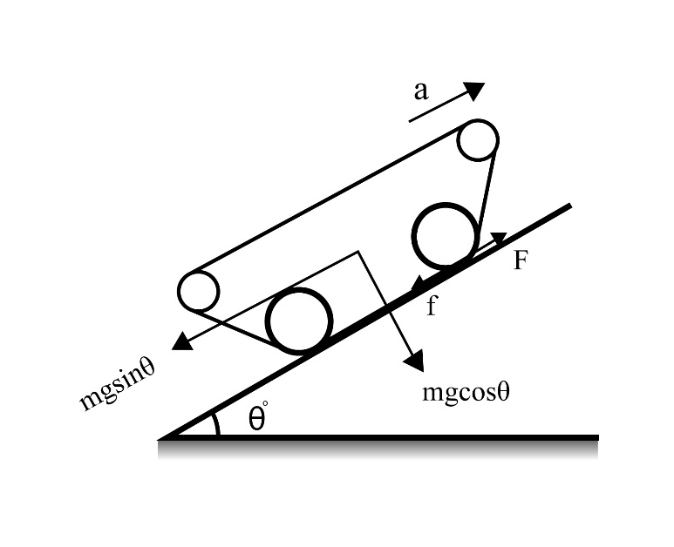

m = 30 kg, a = 0.1 m/s2, μ = 0.33, θ = 20**°**

F-f – mgsin20**°**= ma

f = μmgcos20**°** = 91.262 N

F = 194.91 N

T = 13.6443 Nm

Teach wheel = 3.41 Nm

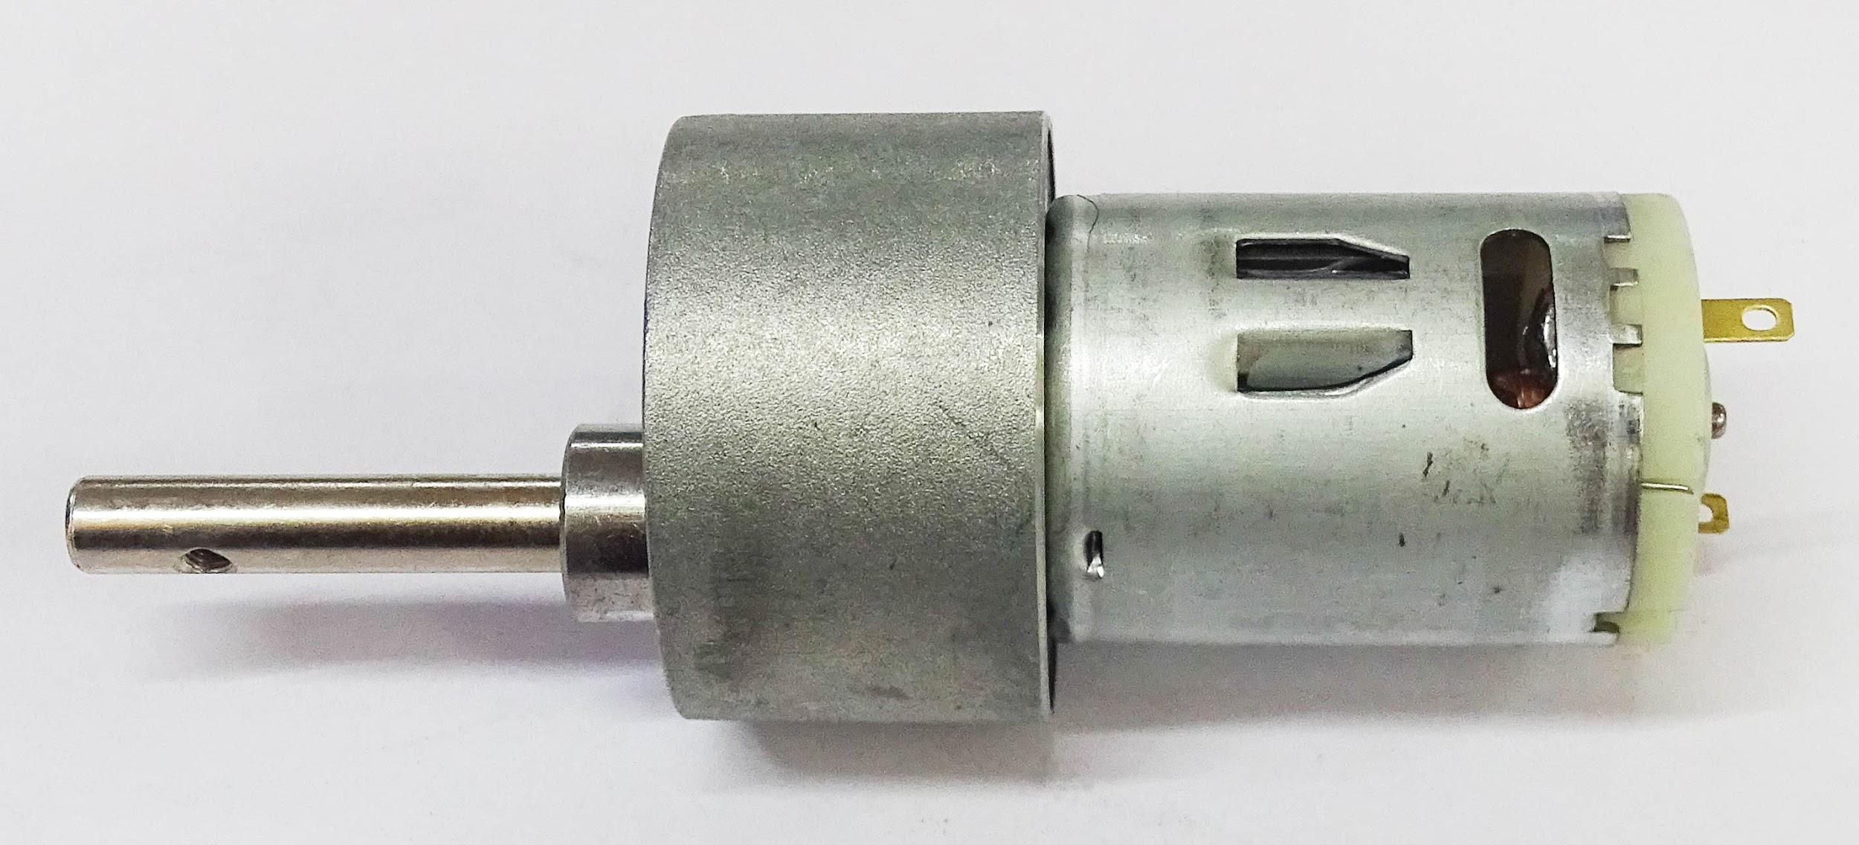Hence, we selected the drive motors with the following specifications-

* 18000 rpm base motor
* 3.5 Nm Torque
* No-load current = 800 mA
* Load current = 7.5 A (Max)

The Motor Used

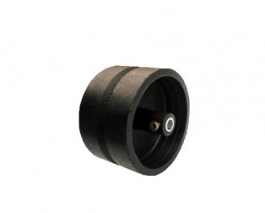

**Wheels & Pulleys**

Four 7 cm diameter wheels are used along with four 10 cm diameter wheels. There are grooves in wheels to support belt to stay intact.

Currently, high grade plastics and wheels are used but cast-iron wheels and pulleys should be used ideally.

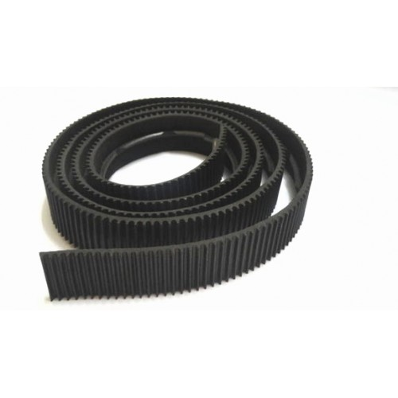

**Belt (Rubber)**

Belts have been used to provide more surface area, which helps robot to traverse in all terrains. The length of each belt is cm. Currently rubber belts are used but ideally metal belts are used.

**Rotating Platform**

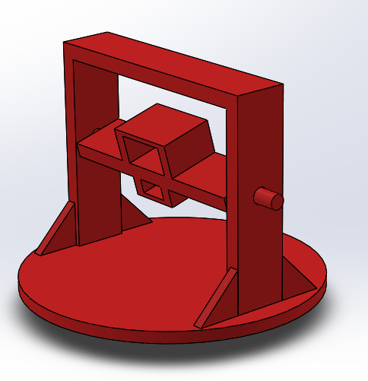A rotating platform is placed on the top of the chassis to increase the bot’s reach and flexibility. The rotating platform is coupled with a 10 rpm DC motor and an encoder is used to provide the current angle of the platform w.r.t chassis. Castor wheels are used at the bottom to ensure that the weight of platform is balanced and free rotation w.r.t chassis is done. It is mounted with the outlets of both the water and the fire extinguisher at an optimum height to increase the reach as well as maintaining a low center of gravity. A servo motor is used on the rotating platform for the longitudinal motion of the water and extinguisher hose outlets. PIR sensor and the IR camera are mounted on the top of the platform. With the help of such flexibility, the firemen will be able to precisely aim the water and fire extinguisher outlet at the right flame center.

CAD Model of Rotating Plate

Following motor has been used for rotating platform-

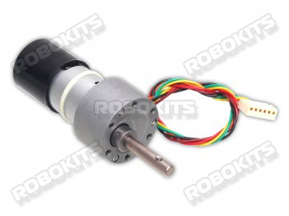

* Motor with Quad encoder
* 10RPM 12V DC motor
* 265680 Counts per Revolution.
* 120kgcm torque
* No-load current: 800 mA, Load current: upto 7.5 A(Max)

**Fire Extinguishing Mechanism**

**Water based extinguishing**

Water from any accessible water supply is fed through fire hose through a nozzle which is then fed to a quarter turn brass faucet valve. The valve is coupled with a servo motor to regulate the flow of water through it. The valve is then connected to a fog nozzle for increasing area of impact of water, and to adjust it’s suitability accordingly.

Due to some unavoidable constraints, in our working prototype, we have used a rubber pipe and PVC pipe extensions to connect and regulate water supply instead of a fire hose.

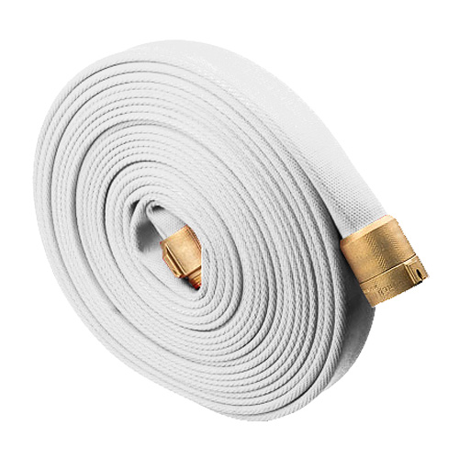 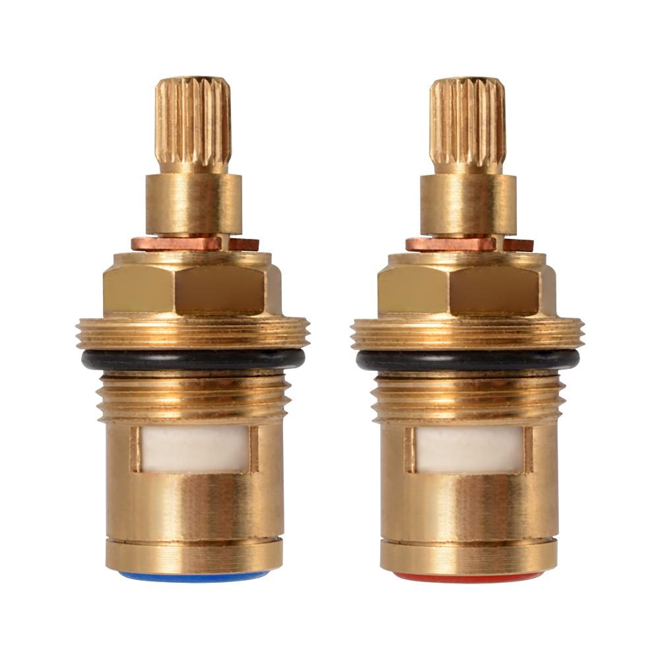 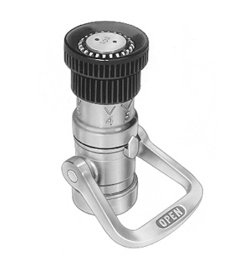

Fire Hose Quarter Turn Brass Valve Fog Nozzle

A servo motor is coupled with the valve to control the flow of water. The movement of the servo motor is constrained to 90 degrees via microcontroller board (Arduino Mega2560), i.e. 0 for no flow of water and 90 for unrestricted flow of water from the source.

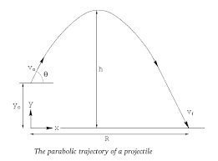Servo mechanism is used for precise angular movements. It is used to control the angle of elevation of the nozzle (θ) thereby controlling the range of action of the fire extinguisher. If the nozzle is inclined at an angle of θ to the horizontal, then it will follow the projectile trajectory equation:

$$y = x×tanθ - g×x^{2}/2×u^{2}×\cos^{2}θ$$

Where

y=height;

x=range;

u=initial velocity

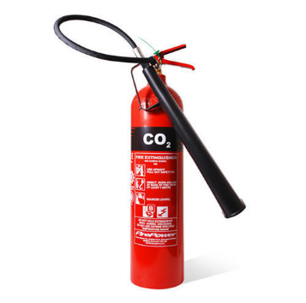**Carbon dioxide-based extinguishing**

A fire extinguisher is used to extinguish fires where water can’t be used. The extinguisher can be replaced as per requirement.

We have used Carbon Dioxide Fire Extinguisher with nominal charge of 2 kg (±5%) constructed according to the requirements of IS 7285, cylinder bodies are PESO approved. Brass forged discharge Valve confirmed to IS 3224.

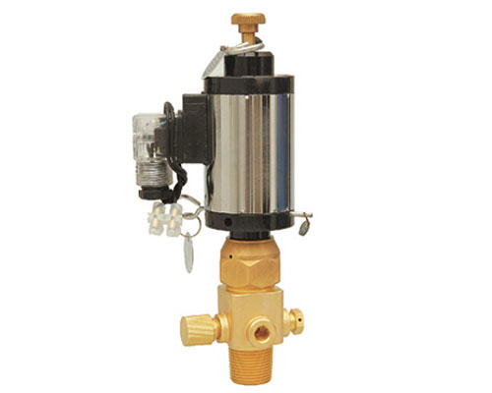Extinguisher is triggered using a solenoid valve operating at 24v DC working voltage. Voltage is provided by the battery triggered by the microcontroller on receiving a wireless signal from the joystick.

The extinguisher is attached to the hose whose pitch angle is controlled by the servo motor.

Solenoid Valve

**Safety Equipment Compartment**

SAFFV consists of a fire safety equipment compartment in the front side which can be accessed manually. There is a limit to the equipment a human firefighter can carry, but a bot can carry much more with ease.

The fire safety equipment includes -

* First aid kit
* Fire blanket
* Gas mask
* Helmet

As the bot traverses and finds trapped humans, it can interact with them via audio communication and the safety equipment can be accessed.

**Electronic Architecture**

**Power system**

The robot is primarily powered a 12V 7Ah Lead Acid battery. The use of Lead Acid battery is due to better safety as compared to that of a lithium polymer battery in heated surroundings. Different components have different current and voltage ratings which are provided with the help of the power circuit. All the DC geared motors work on 12V whereas the Raspberry PI, Arduino Mega, Servo motors have been provided with 5.6V. The rest sensors like PIR have been provided with 5V. The current ratings of each component have been taken into consideration and respective fuse have been used in the power circuit. The voltage regulation is done with the help of buck-boost converters.

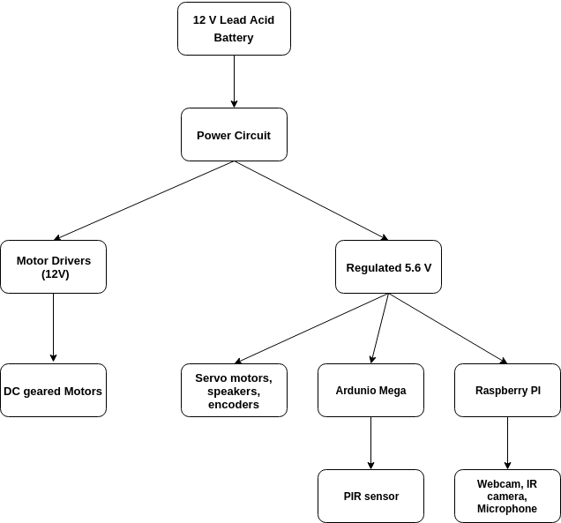

**Key Components**

**Motor Drivers**

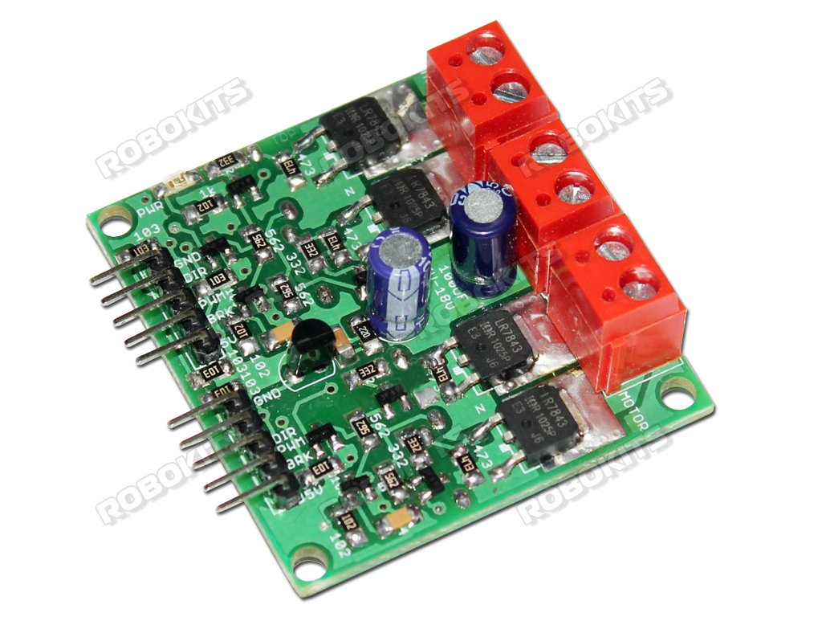The 4 high torque dc motors used for drive, are controlled using a dual dc motor driver capable of handling currents up to 20A. The front and rear motor of a side is coupled and the max load current for each motor is 7.5A. Thus, we have used a motor driver handling the current of more than 15 A.

* Capable with motors rated between 6V - 18V
* Current delivering capability of up to 20A
* Can be operated with 10KHz PWM to control the speed of the motors.

For the rotating platform, we have used a dual dc motor driver having a rating of 5A.

**Arduino Mega 2560**

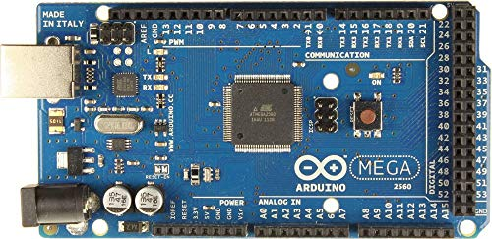The arduino mega 2560 has been used to control the motors drivers, servo motors, encoders and other sensors like PIR.

* Microcontroller - ATmega2560
* 16 MHz clocking speed, 256 KB of flash, 8 KB of SRAM and 4 KB of EEPROM.
* 54 digital I/O pins(15PWM), 16 analog inputs, 4 UARTS

**Raspberry PI 3B+**

The raspberry PI 3B+ is the central controller of the whole robot. The camera feed processing and all the wireless communication is done through the PI with the help of its inbuilt 5GHz Wi-Fi.

* 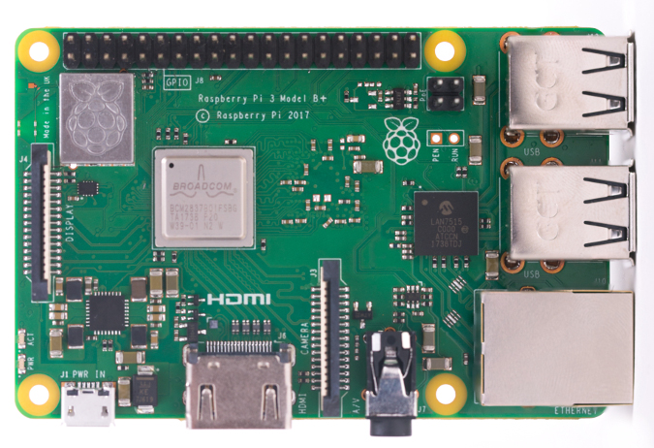Broadcom BCM2837B0, Cortex-A53 (ARMv8) 64-bit SoC @ 1.4GHz
* 1GB LPDDR2 SDRAM
* 2.4GHz and 5GHz IEEE 802.11.b/g/n/ac wireless LAN, Bluetooth 4.2, BLE
* Gigabit Ethernet over USB 2.0
* CSI camera port for connecting a Raspberry Pi camera
* 4-pole stereo output and composite video port
* 5V/2.5A DC power input

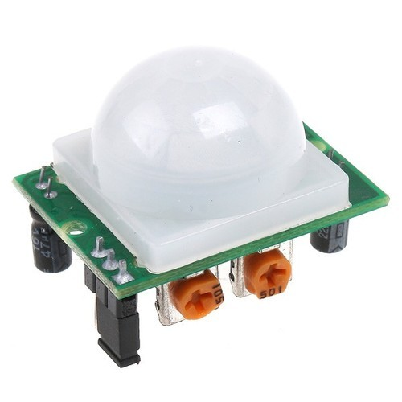**Passive Infrared Sensor**

The Passive Infrared sensor is used for detection of human beings by use of a pyroelectric infrared sensor which detects the change in infrared radiations due to humans.

* Range - up to 12m in 120 degrees wide angle
* Output-Digital pulse high (3V) when triggered (relative motion detected) digital low when idle (no motion detected).

**Metal Oxide Gas sensors**

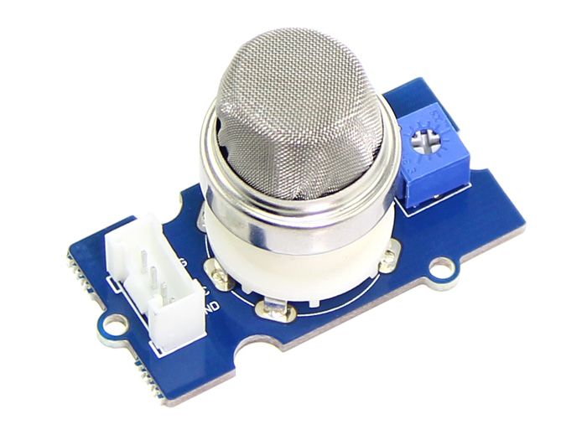MQ9 gas sensor has been used to provide the approximate level of CO, LPG or Methane in the air. The presence and cause of the fire can be approximated with the help of this sensor. For example, the butane concentration will be high in case of fire caused due to cylinder leakage. MQ2 gas sensor is primarily used for monitoring the smoke level in the air. It also has the capability of detecting some other combustible gases.

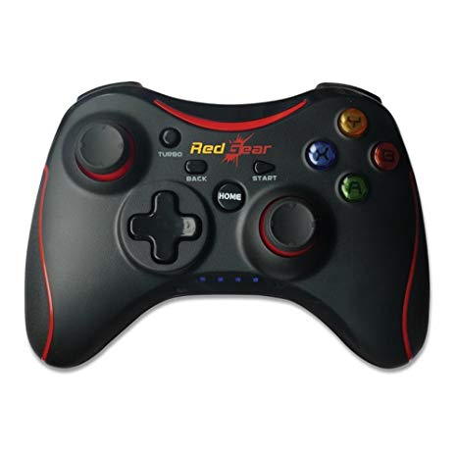**Wireless controller**

A wireless gamepad has been used for the wireless control of the robot. All the motors used for locomotion, rotating platform, water flow, fire extinguisher, nozzle pitch, etc. are controlled using this controller.

* 2.4 GHz frequency
* 11 digital keys
* 2 analog sticks, 2 analog triggers

**Servo**

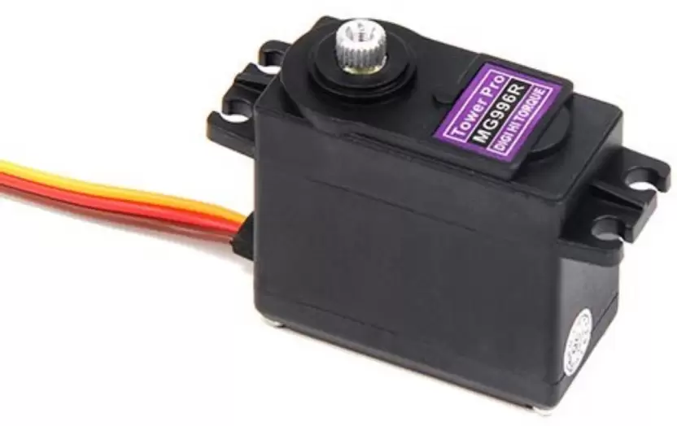Two servo motors (MG996R) have been used in the robot, for controlling the flow of water and for changing the pitch angle of the nozzle.

* High Speed Torque Digital Servo with Metal Gearing
* Operating Speed: 60/0.14 degree/second (No Load @ 6.0V)
* Stall Torque: 12 kg/cm @ 6V
* Running Current 500mA - 900mA @ 6V
* Stall Current 2.5A @ 6V

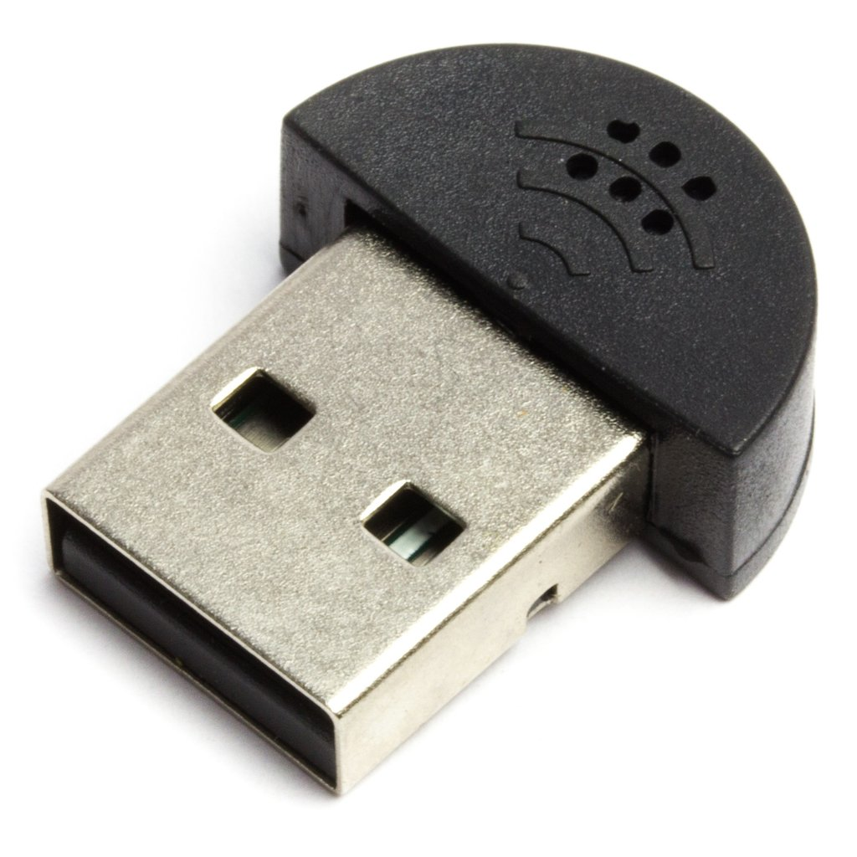**USB microphone and speakers**

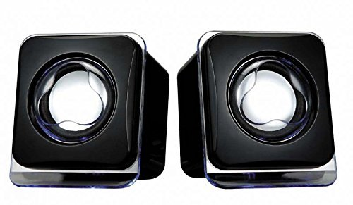The two-way audio communication between the person controlling the robot and the robot is achieved with the help of an external USB microphone and speakers.

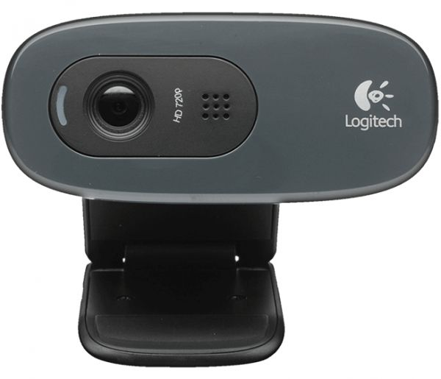**Logitech C270 Webcam**

The camera is mounted on the chassis whose feed is primarily used for the locomotion. It is also used to temporarily monitor the fire in front part of the robot when the thermal imaging camera is facing some other direction.

* Field of View - 60°
* Video Capture (16:9 W) - 360p, 480p, 720p
* Frame rate - 30fps @ 640x480

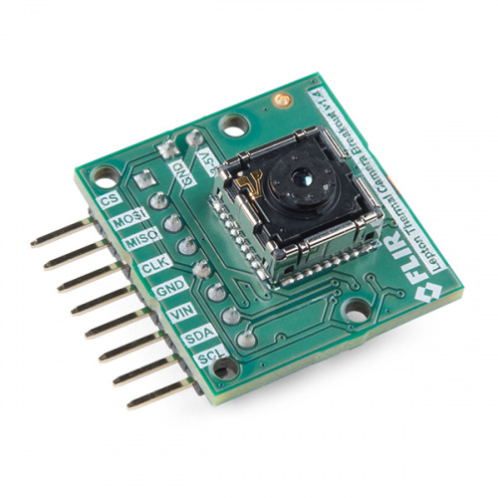**Thermal Imaging camera**

The FLIR Lepton 3.5 thermal imaging camera has been proposed to use for producing the heat map of the area. This camera is the heart of the robot. It is able to distinguish humans, fire and debris even in thick smoke.

* Spectral range - Longwave infrared, 8 μm to 14 μm
* Thermal array format - 160 x 120, progressive scan
* Effective frame rate - 8.7 Hz
* 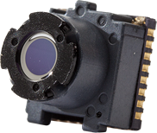Thermal sensitivity - <50 mK (0.050° C)
* Scene dynamic range - -10° to +450° C
* FOV - horizontal - 57°
* FOV - diagonal - 71°
* Video interface - Video over SPI
* Power dissipation - Nominally 150 mW (operating)

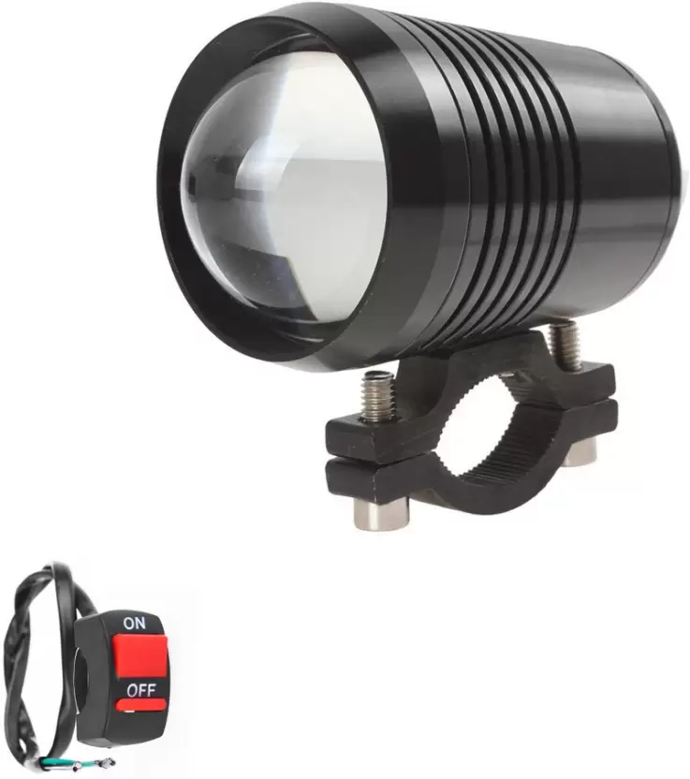**Fog Lamp**

A fog lamp is attached to the front part of the robot which assists vision during night and also during thick smoke.

**Software Architecture**

**Communication**

The whole robot works on Robot Operating System (ROS) platform. The Arduino Mega and the Raspberry PI are the major components. The input from various sensors like gas sensors, encoder and PIR sensor is read from the arduino and sent to the Raspberry PI via a topic. This data is further hosted on a local server which can be accessed by a client device.

The joystick is used to send commands for various motors and servos. Even the fire extinguishing mechanism is triggered by the joystick. To achieve this, the data received from the joystick by the Raspberry PI is processed and sent back to the arduino as commands. This can be understood in detail from the figure given below-

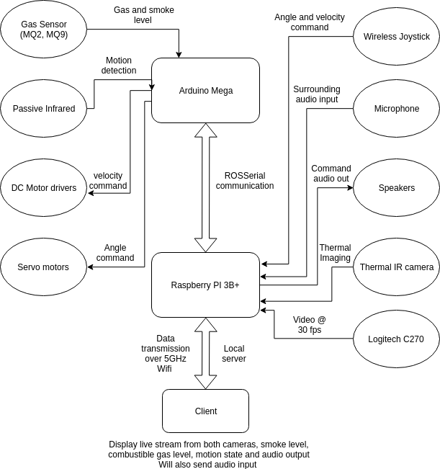

**Imaging and Audio**

The FLIR Lepton 3.5 is the most important part of the whole robot. It is capable of producing thermal images of size 160 x 120 at an impressive rate of more than 8 fps. This colorful thermal image can be easily used to point out the fire and also spot humans in presence of thick smoke. The thermal camera feed is processed and hosted on a local webserver which can be streamed from a client device. This camera is mounted on the rotating platform which allows human detection in all directions. Due to some constraints, the FLIR Lepton 3.5 thermal imaging camera has not been used. Instead an IR camera with night vision has been used for the prototype model.

A Logitech C-270 webcam is mounted on the front side of the robot. Its feed can also be streamed simultaneously along with the sensor data and the thermal camera on a client device. Its major use is to get vision in direction of motion of the robot so that the bot can be maneuvered without hitting obstacles.

Speakers and USB microphone are attached to the Raspberry PI. The microphone records live audio and streams it over the local server. Similarly, on the other side, the person controlling the robot can send voice commands to the robot which are amplified using speakers. They can assist the survivor in accessing the safety equipment box for gas mask and other equipment.

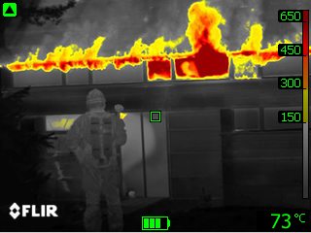 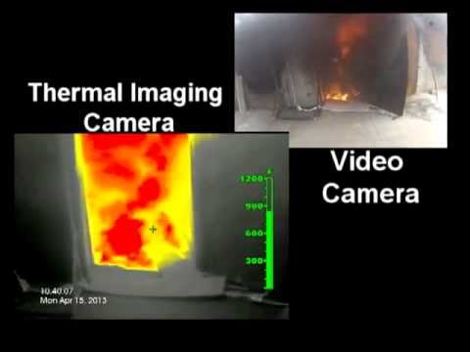

Screenshot of FLIR Lepton 3.5 Video Feed as compared to normal camera

**Cost Analysis**

Following is the rough estimate for building the SAFFV. The price taken into account is that of the real robot and not that of the prototype bot.

|  |  |  |  |
| --- | --- | --- | --- |
| **Component name** | **Quantity** | **Rate (In Rs.)** | **Cost (In Rs.)** |
| Raspberry Pi 3B+ | 1 | 2750 | 2750 |
| Arduino Mega (2560) | 1 | 850 | 850 |
| High Torque DC motors (100 RPM) | 4 | 450 | 1800 |
| High torque DC encoder motor(10RPM) | 1 | 1100 | 1100 |
| 20A motor driver (12V) | 1 | 600 | 600 |
| MG996R servo motor | 2 | 300 | 600 |
| 5A motor driver (12V) | 1 | 250 | 250 |
| MQ9 gas sensor | 1 | 130 | 130 |
| MQ2 gas sensor | 1 | 140 | 140 |
| PIR sensor | 1 | 100 | 100 |
| 7Ah Lead Acid battery | 2 | 900 | 1800 |
| Fog lamp | 1 | 400 | 400 |
| Misc. electronics | 1 | 500 | 500 |
| FLIR Lepton 3.5 Thermal IR camera | 1 | 20000 | 20000 |
| Logitech C-270 Webcam | 1 | 1500 | 1500 |
| mini usb microphone | 1 | 200 | 200 |
| mini speaker | 1 | 170 | 170 |
| 32 GB micro SD card | 1 | 500 | 500 |
| Wireless Gamepad | 1 | 900 | 900 |
| 10 cm diameter wheels (4cm thick) | 4 | 100 | 400 |
| 7cm diameter pulley (4cm thick) | 4 | 60 | 240 |
| Tank track belt (1m) | 4 | 200 | 800 |
| Motor mounts | 5 | 25 | 125 |
| Castor wheels | 4 | 30 | 120 |
| Chassis material and fabrication | 1 | 8700 | 8700 |
| Fire extinguisher CO2 (2 kg) | 1 | 2000 | 2000 |
| Solenoid valve (24V) | 1 | 1000 | 1000 |
| Fog nozzle | 1 | 500 | 500 |
| Gas mask | 1 | 750 | 750 |
| Fire blanket | 1 | 300 | 300 |
| Helmet | 1 | 500 | 500 |
| First Aid kit | 1 | 200 | 200 |
|  |  |  |  |
| **Total** |  |  | **49925** |

Since the product is specially designed for the fire department, most of the costs related to fire extinguishing including CO2 fire extinguisher, nozzle, gas mask, etc., will be cut down due to their availability with the fire department.

**Future Aspects**

* SAFFV can be made fully autonomous by use of computer vision and various sensors. IMU, GPS and encoders can be used for localization. Human detection is easily possible on thermal imaging camera.
* Stair climbing mechanism.
* Implementation of fire and smoke detection through normal camera with the help of object tracking. For this, a region of interest is first chosen with thresholding color levels. The pixels in that region are then tracked. In case it is a smoke or flame particle it would be seen as a moving pixel. In this way, fire can be detected. This will only work when the bot is stationary.
* Can be introduced as a commercial product for homes and industries integrated with their fire alarm systems, and it’s inbuilt gas sensors for safety monitoring purposes and autonomous fire extinguishing in case of fire.
* Autonomous flame targeting and extinguishing. The nozzle will target and lock on to the flame even if the bot is moving in other direction and by use of contactless infrared thermometer, it will sense when the flame is extinguished.
* Long range communication using antennas or gprs protocol.

**References**

* <https://www.arduino.cc/>
* <https://www.raspberrypi.org/>
* <https://www.flir.com/globalassets/imported-assets/document/lepton-3-3.5-datasheet.pdf>
* <http://wiki.ros.org/joy>
* <https://github.com/Motion-Project/motion>
* <https://learn.adafruit.com/pir-passive-infrared-proximity-motion-sensor/how-pirs-work>
* <http://wiki.seeedstudio.com/Grove-Gas_Sensor-MQ2/>